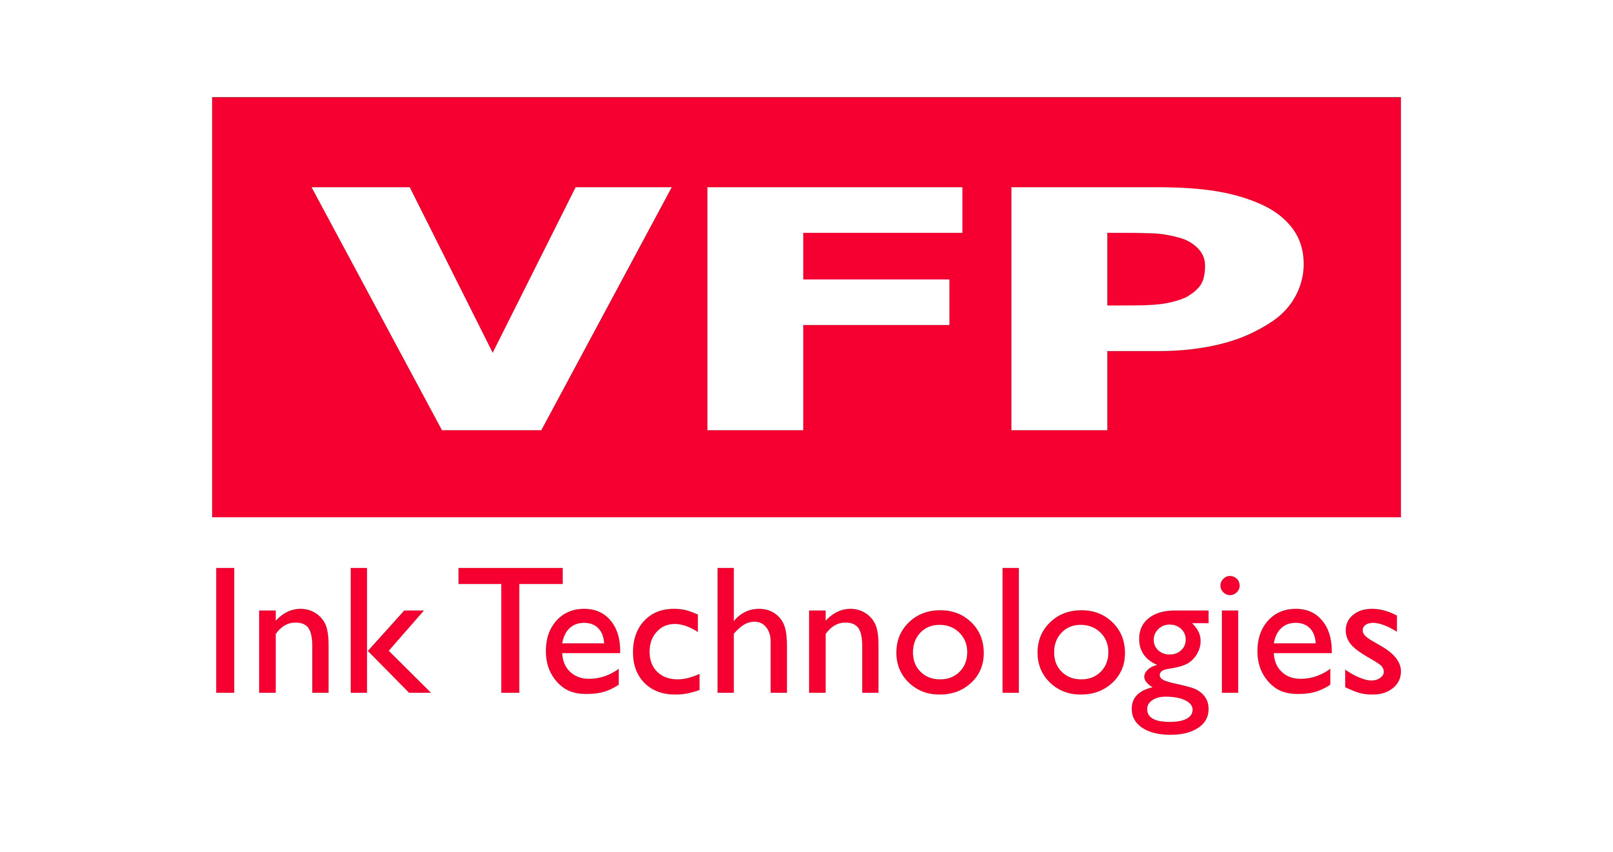

CES 2019

VFP Ink Technologies presents its high-tech Inks
Designed for the automotive industry of the future
At the Las Vegas CES

LVCC Central Plaza – Pavilion CP-4

VFP Ink Technologies is one of 10 French SMEs selected by “French Tech and Business France” to participate in the acclaimed Las Vegas CES 2019. Specialized in the design and manufacturing of ground breaking inks and varnishes, It will unveil to the public its printed electronics innovations for the vehicles of the future. With its R&D team comprised of highly skilled Chemical Engineers, VFP Ink Technologies manufactures high-tech functional inks designed for industrial use with cutting-edge technology. VFP also works in collaboration with Schneider Electric as part of an applied research development program on a revolutionary technique in the plastronics field, transposable to the automotive sector.
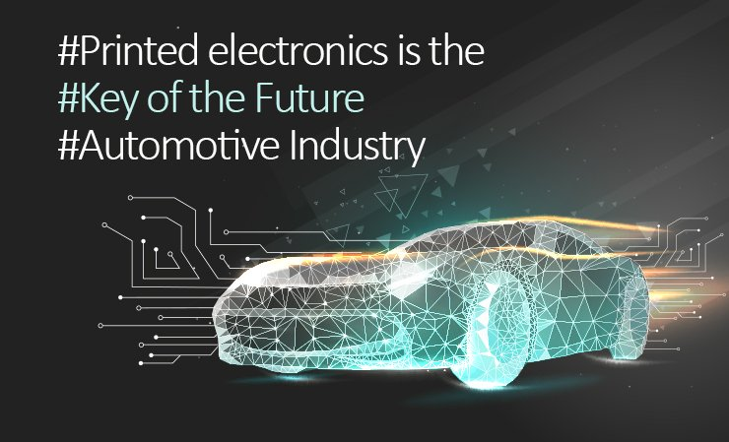

Intelligent Inks for new generation car sensors.
VFP Ink Technologies is building on its expertise of flexible printed electronics by developing conductive inks TF (Polymer Thick Film) based on micron particles for silkscreen printing. These innovative inks are useful for an array of applications like smart packaging, RFID, touch screens and last but not least in the automotive industry.
Indeed, the vehicles of tomorrow will be required to calculate, collect and transmit ever more data on the interior and exterior environment to improve performances in terms of safety, energy consumption and passenger comfort. Flexible printed electronics and conductive inks will therefore be at the heart of new connected technologies in tomorrow’s vehicles.
Car manufacturers are showing a growing interest in the integration of new generation flexible sensors using printed electronics. Various types of sensors will be installed in vehicles, particularly in areas where it was not previously possible, to measure numerous data with temperature and pressure sensors, capacitive or even presence sensors.
The integration of these high-tech sensors will add many benefits, both in terms of weight reduction and reduced environmental footprint. It will also offer some new possibilities in terms of design by eradicating a number of technical constraints related to conventional “rigid” electronics, namely: the functionalization of flexible or rounded surface, valuable space saving and the removal of cables and controls.

An actor involved in an ambitious collaboration on plastronics selected by the government.
VFP Ink Technologies has been selected by Schneider Electric to join the FUI ELIPPSE (Interdepartmental Unique Funds). The purpose of this collaboration is to develop a pioneering technology combining the advantages of printed electronics that will result in a brand new process in plastronics. The plastronics: a contraction in between plastics processes and electronics, allows products to become intelligent. The aim being the optimal integration of electronics into 3D geometrically complex or curved plastic parts.
« VFP Ink Technologies alongside other actors enabled the realization of this collaboration by providing us with high quality materials a real expertise of the printed electronics sector » explains Cécile Venet, Innovation Project Leader at Schneider Electric. « The plastronics is a growing success, which not only brings added value but also allows the creation of products that are impossible to manufacture with traditional technologies, particularly in the automotive sector. By removing and replacing the electronic board of a car and all of it’s connections with some new generation sensors, it is now possible to not only reduce the weight of a vehicle but to create new shapes for auto parts, outside and inside the passenger compartment like the center console, the dashboard, the doors, the steering wheel etc.

Contacts press

Agence Wellcom – +33 1 46 34 60 60
Sarah Nascimento & Stéphanie Piere
vfp@wellcom.fr

About VFP Ink Technologies :
VFP Ink Technologies devises high-tech inks and varnishes for today’s and tomorrow’s industries.
It perpetually challenges itself and offers new prospects for the future of mobility thanks to flexible electronics accessible to all.
This newly created technology opens the doors to a future previously unthinkable and can adapt itself to all constraints and to every automotive developer or supplier to foresee revolutionary, innovative, and tailor-made finished products.
French SME, expert in consumables and high-tech printing technologies, VFP is involved in many research and collaborative industrial projects and brings new durable solutions such as the latest developments in plastronics.
A major European player, VFP Ink Technologies distributes its full range of products and expertise in 5 continents.

